June 2018
Inclusive Education:
Ensuring Access and Quality Education to Marginalized Children in Nepal

Impact evaluation of School Sector Reform Plan Additional Financing of World Bank to marginalized children
BIBEK LUITEL
Vice-Chairperson/Senior researcher
BAL KSHETRA NEPAL

PRATIMA GURUNG
PRESIDENT
NATIONAL INDIGENIOUS DISABLED WOMEN ASSOCIATION NEPAL

Acknowledgements

During the study and preparation of this report, we have benefited from numerous individuals and institutions. We are grateful to those various students, parents, caregivers, teachers, head teachers, school management committee members, education administrators, education activists, human rights activists, WB staff at Kathmandu office and at Headquarter, educationist etc. for their time and information required for the study.

Finally, we are grateful to Bank Information Center for supporting this study and special thanks to Rachel Burton for her continuous support and assistance.

Thank you all.

Bibek Luitel
(bibek.luitel@outlook.com)
Pratima Gurung
(mailmepratima508@gmailcom)

June 2018

Acronyms

BP | Bank Procedures
CAS | Continuous Assessment System
CBS | Central Bureau of Statistics
CDC | Curriculum Development Center
CEDAW | Convention on the Elimination of all form of Discrimination Against Women
CRC | Convention on the Rights of the Child
CRPD | Convention on the Rights of the Person with Disability
DEO | District Education Office
DoE | Department of Education
EFA | Education for All
EMIS | Educational Management Information System
ERO | Education Review Office
ESS | Environmental and Social Standard
GoN | Government of Nepal
ILO | International Labor Organization
MDG | Millennium Development Goal
MoE | Ministry of Education
NASA | National Assessment of Student Achievement
NDHS | Nepal Demographic and Health Survey
NLSS | Nepal Living Standard Survey
NPC | National Planning Commission
OP | Operational Policy
SDG | Sustainable Development Goal
SSDP | School Sector Development Plan
SSRP | School Sector Reform Plan
UDHR | Universal Declaration of Human Rights
UNICEF | United Nations Children Fund
VCDF | Vulnerable Community Development Framework
WB | World Bank

Executive Summary

The government of Nepal is implementing several education interventions to provide education to all children in the country, yet many marginalized children are still not properly integrated in mainstream educational practices. The World Bank is working with the government of Nepal to address the school level education issues and intervene through educational projects. School Sector Reform Plan (SSRP) additional financing is one of them. This study aims to demonstrate the impact of SSRP additional financing project to marginalized children in both project design and implementation and highlights challenges with the project that should be addressed in the School Sector Development Plan (SSDP).

School Sector Reform Plan was one of the major reform initiatives taken by the government of Nepal to address access and quality of school education for all children. This project focused on improving access and quality of school education from grade 1 to 8 especially for children from marginalized groups such as: dalit children, girls, children with disability, highly marginalized indigenous children, HIV infected children, working children, street children and conflict affected children. Despite targeting to above mentioned marginalized groups, consultations were not held with marginalized groups during the design phase of the project. Though public dialogue was required for such a large-scale project design, not been enough dialogue among stakeholders. Because of lack of consultation with parents and children especially from HIV infected group, LGBTI group and children with disability group in design phase, their needs and concerns were not addressed in implementation phase. Moreover, multiple diversity within the marginalized group and intersectionality has not been considered, and existing education act was not fully supportive to implement the SSRP at the time of project preparation. Therefore, design of the project was not fully inclusive.

Furthermore, on the implementation side, we found that there is room for improvement in physical and psychosocial environment along with services provided to students in schools. Most of the schools do not have child and disabled friendly infrastructure. Children with disability are facing challenges in accessing school. Still many HIV infected children, dalit children and LGBTI children are facing discrimination at school. In the learning process, the teachers are not fully competent, despite taking training. Frequent absenteeism of teachers in the classroom is also a serious problem which hampers quality education. Learning content has found enough but the prescribed pedagogy is not appropriate, and learning materials are also lacking in most of the schools. Provision of mother tongue education has not been implemented properly, therefore, indigenous children have limited learning outcomes. Home, community and school relation has not been strong which has negative impact in students’ quality education. Many equity measures have taken to increase access to education but only free textbook and mid-day meal are effective. Still 10 to 15 percent school aged children are out of the school system in which children with disability are significant portion. Working children are still not captured by the project implementation. The project was targeting the above mention marginalized groups but all children from these groups are yet to be integrated in the school system, therefore, implementation of the project is also not fully inclusive.

Table of Contents
Acknowledgements ii
Acronyms iii
Executive Summary iv
Introduction 6
Study Objectives and Questions 6
General Background 7
Existing Context 7
Current Issues 8
Policy Context 8
Intervention Project (SSRP Additional Financing) 10
Findings and Discussion 11
Designing of the project (SSRP AF) 12
Implementation of the project (SSRP AF) 12
Learning Environment 12
Learning Process 14
Learning Content 16
Learner’s Condition 17
Equity and Access 18
Lessons and Recommendations 21
References 22
Annex – 1 Field Photographs 24

Introduction

Responding to the importance of education, the Government of Nepal has been spending the highest amount of public expenditure on the education sector compared to other sectors. The World Bank also has been involved in providing support to the education sector through the government for more than three decades.

This study aims to demonstrate the quality and access for marginalized children to school education that was targeted by the systemic reform project ‘School Sector Reform Plan: Additional Financing’ which was partly funded by The World Bank. The project covered all the schools across the nation with the goal to improve access and quality of school education particularly from ECED and grade 1 to 8 especially for children from marginalized groups. Moreover, it also explores whether design and implementation of the project is properly enacted and has positive impact on marginalized children such as: dalit children, girls, children with disability, highly marginalized indigenous children, HIV infected children, LGBTI community children, working children, religious minority children etc. of the country. To meet these aims, the study investigated five critical areas such as: learning environment, learning process, learning content, learner’s condition and access to education of marginalized children. To ensure access to quality education, these five dimensions are prominent to evaluate and investigate. In the context of Nepal, these dimensions are critical to look at since educational reform would be rhetoric without transforming in these critical prominent areas of education.

Study Objectives and Questions

The study objectives are to:
- examine the quality and access of school education of marginalized children during SSRP additional financing project intervention;
- explore whether the project has been designed to address the issues of marginalized children’s education and whether the project was implemented in an inclusive way;
- identify the impact of SSRP additional financing on marginalized children in their educational pursuit;
- highlight gaps in SSRP and propose recommendations for change in SSDP.
The study guided by the following questions:
- How does physical and psychosocial environment impact the quality of education?
- How are the teaching, learning and supervising processes linked with quality educational outcomes?
- Does curriculum and study materials impact learning objectives?
- How does psychosocial development of children, and home, community and school relations matters for marginalized children’s education?
- What are the measures to access school education for marginalized children?
- How are the safeguards operationalized in grass root school educational practices?

General Background

Existing Context
The educational policy makers of Nepal have sought to develop high quality public education system through multiple interventions with the aim to address major three areas: increase equity and access; improve quality and relevance; and strengthen the institutional capacity of the system to address the first two areas. A few national educational policy initiatives have been complemented by foreign aid through different bilateral and multilateral organizations including World Bank.

The current secondary school system is providing three types of education such as: general, Sanskrit and technical & vocational education. The school system has adapted different types of schools such as: community schools (government aided), institutional schools (registered under company act, for profit making), trust school (for not profit making), special schools (for children with disability), religious schools (Gurukul, Monastery and Madrasah), and alternative schools. The data showed that there were 35,222 schools all together which comprises 34,920 basic schools (form grade 1 to 8), 9,379 secondary schools (from grade 9 to 12 or grade 1 to 12), 1,066 religious schools, 32 special school and very few trust and alternative schools. There were 59,94,612 students enrolled in basic education and 13,89,650 students enrolled in secondary education in the beginning of academic year 2016/17. Based on the government data, 50.5% girls and 49.5% boys are enrolled in basic school and 52.7% girls and 47.7% boys are enrolled in secondary school in the same year. It shows that the Gender Parity Index (GPI) is almost levelled. The Net Enrollment Rate (NER) was 91% in basic education and 38.9% in secondary education which indicates that the significant number of children are still out of school system. The school system tries to incorporate different groups of students in the system with introducing the various mode of schooling such as: special education, inclusive education, non-formal education, continuous education, distance education and open school education etc.

The population census 2011 showed 26.5 million inhabitants with 126 different cast/ethnic groups who speaks 123 different languages. This diversity could be a good developmental resource; however, historical hierarchical structural social practices have differential access to economic, political and socio-cultural resources to the groups of the people and the marginalization of some groups with continuing inequity in the society. Most of socio-cultural and political practices in Nepal are largely discriminatory and exclusionary and are reflected in: gender; socio economic status; location; health and nutrition status; physical condition of person; cast and ethnicity; language; and vulnerability groups. With such a tradition, large numbers of people are deprived of their educational rights and equity in education remains a constant challenge in the country. To address the inequity in education with the goal of mainstreaming marginalized groups, the Government of Nepal developed the consolidated equity strategy in 2014 which identified three equity areas and eight equity dimensions. The equity strategy is directly applicable to the marginalized or vulnerable groups such as: dalit children, children with disability, girls, domestic child labor, street children, conflict affected children, HIV infected children, highly marginalized and engendered indigenous children which were identified by vulnerable community development framework.

Current Issues

In spite of many initiatives to reform the education sector, the question on access and quality of education to marginalized children in basic and secondary level has remained crucial. The study showed that 10 to 15 percent of children of basic education age group are still out of school. It has become a crucial task of government and education stakeholders to identify who these children are and how to bring them into the school system. There are nine prominent barriers which prevent children from accessing school or have a high potential to dropout from school; such barriers are: poverty; social exclusion linked to cast/ethnicity; disability; migration, child labor and trafficking; social norms and gender biases; supply constrains; school infrastructure and staffing; language; emergencies and civil strife; governance and financing bottlenecks etc. Multiple strategies have been adapted to address such barriers and open the door for ‘Education for All’. The concern of quality of education has become critical because the general quality standard has become very low. Moreover, the disparity has been observed in learning achievement among students. The marginalized groups of children have low learning achievement compared to their counterpart. The initiatives to improve the quality education also has been taken in subsequent interventions.

Policy Context

The policies relating to education have direct and indirect effect on the attainment of education for all children. The international and national policies are reviewed to understand the broader view of existing situation of Nepalese education sector.

International Policy Context:
As a member of United Nations, Nepal has ratified a few conventions to secure the rights of the marginalized communities of the country such as: Rights of the Children (CRC), Convention on the Elimination of All forms of Discrimination against Women (CEDAW), ILO 169, Convention on the Rights of the Persons with Disability (CRPD) have become the monitoring tools for the educational access and quality of children from marginalized groups. Moreover, millennium development goals (MDG) and sustainable development goals (SDG) have been helping to align the educational goal of the nation with the specified educational indicators. Becoming a party to these conventions and program of UN has been little help for the educational pursuit of girls, indigenous children, dalit children and children with disability.

National Policy Context:

As a primary law of the nation, article 31 of the constitution has mentioned that education is a fundamental right of the people of the country. The article highlights that every citizen has the right to compulsory and free basic education and free secondary education. It further protects the rights of education of children with disability with appropriate language and script such as: sign language for deaf and braille for visually impaired. The article ensures the rights of indigenous children to study in their own mother tongue and open the school for the promotion of the mother tongue language.

The Education Act, eighth amendment 2016, of Nepal has rationalized the new changes in the act to improve the school management with development of quality education for all children. The Act has addressed the multiple issues in the education sector including the concerns of marginalized and vulnerable children such as: dalit children, children with disability, girls, domestic child labor, street children, conflict affected children, HIV infected children, highly marginalized and engendered indigenous children. In the article 6A, the provision has been mentioned regarding different mode of education such as: special education, inclusive education, non-formal education, continuous education, distance education and open school education (which provides the educational opportunity to students who could not attend school regularly) to targeted marginalized and vulnerable children to be able to access school education.

In addition, inclusive education policy 2017 has been adopted by ministry of education with special focus to ensure the right of education for children with disability. The policy has developed the comprehensive framework for access and quality of education with disabled and child friendly school environment. It has given the emphasis on the special provisions for children with disability with considering the varieties of languages and scripts that has been used by different types of children.

To address the existing widespread inequality in the education sector, ministry of education has developed the consolidated equity strategy in 2014. The aim of the strategy was to solve the deeply rooted problems. It has been identified the three-major equity areas such as: equity in meaningful access, equity in meaningful/functional participation and equity in meaningful learning outcomes. The strategy found out eight prominent equity dimensions and these were: gender, socio economic status, health and nutrition status, geographical location, physical condition of person, ethnic group and or cast, language and children of vulnerability groups etc. Some of the measures that have been recommended were: incentive schemes, health and nutrition programs, advocacy and campaign, enabling learning environment, affirmative action policies and legislation, alternative education, inclusion of children with disability and partnership and network. Despite of these all policy and provisions, it has seen that there is still huge gap in policy and practice to ensure the access and quality of education to all children in the country.

Intervention Project (SSRP Additional Financing)

School Sector Reform Plan (SSRP) was one of the important reform initiatives taken by the government in the education sector which aimed to provide a unique opportunity to marginalized children for their basic and secondary education. This plan had a seven year systemic intervention from 2009 to 2016 that covered the entire school education (grade 1 to 12) along with early childhood education and development (ECED) and non-formal education (NFE). The plan was divided into two segments as first five years and two years’ extension.

The SSRP was standing on three pillars: enhancing access, promoting inclusion and improving quality in basic and secondary education which were pertinent aspects to address by educational reform initiative. The aim of the plan was to expand access and equity in school education, improve quality and relevance, and strengthen the institutional capacity of educational administration system. Originally the main objective of the project was ‘to improve access to, and improve the quality of, school education, particularly basic education (Grade 1-8), especially for children from marginalized groups.’ The specific objectives of the SSRP were:
- Ensure equitable access of quality basic education for all children (aged 5-12 yrs.);
- Expand access to Early Childhood Education and Development (ECED) services for children of 4 years to facilitate their holistic development and to prepare them for basic education;
- Enhance functional literacy and competencies among the youth and adults;
- Increase access to, and equity, quality and relevance of secondary education;
- Equip secondary level students with soft skills based technical and vocational education;
- Improve the performance of the MoE service delivery system and develop capacity to implement critical reforms;
- Enhance teacher qualifications and professional competencies to facilitate student learning;
- Monitor programme inputs, processes, and outputs and evaluate the impact of education interventions;
- Improve the efficiency and effectiveness of aid available for the SSRP.

The project originally involved three components:
- Component 1: Basic Education: Ensure equitable access and quality basic education for all children age groups 5-12 (Total: US $2.067 Billion; Appraisal estimate: IDA US $102 million, additional financing US $223.81million, actual US $292.9 million)
- Component 2: Secondary Education: Improve access, equity, and quality and relevance of secondary education (Total: US $512 million; Appraisal estimate: IDA US $25 million, additional financing US $33.9 million, actual US $70.4 million)
- Component 3: Institutional Capacity Strengthening: Improve capacity of the SSRP implementation agencies and its partners to enhance delivery and monitoring of education services and products (Total US $57 million; Appraisal estimate: IDA US $3 million, additional financing US $5.66 million, actual US $7.4 million)

The SSRP original project has been designed to spend 70% on primary education sector and 30% on secondary education sector. The expenditure was expected to address the Education for All program and other social development with the ratio of 67% and 33% respectively. Around 80% of the project cost was born by the government of Nepal and 20% was committed by development partners.

The estimates (done by World Bank around 2013) indicated a financing gap of around US $210 million for the first five years of the program (ending July 2014) and US $622.7 million for the full seven years’ program period (ending July 2016). Therefore, the Additional Financing (AF) was proposed to the Bank which would enable the Government of Nepal to partially address the pressing financing gap of SSRP and continue implementing the originally planned activities. The purposed of the AF would support SSRP through the original three components; however, restructuring under the AF would: (i) introduce Incentive Linked Indicators (ILIs) (The indicators were: percentage of teachers received salary through bank; delivery of scholarship to beneficiary students; percentage of students in grade 1 to 8 receive textbooks within two weeks of start of classes, and preparation and implementation of the National Assessment of Student Achievement plan) to partially finance the Annual Work plan and Budget (AWPB) in order to further improve service delivery and enhance key quality and governance and accountability outcomes; (ii) revise the Result Framework; and (iii) extend the original project closing date from December 15, 2014 to July 15, 2016 in order to fully implement the governance and accountability measures. The closing date would be aligned with the Government’s 7 year timeframe of SSRP and the GoN’s fiscal year.

To continue this educational program, the government of Nepal proposed the School Sector Development Plan (SSDP) in 2016 which was the successor program of SSRP and has seven years of implementation period. A few development partners and the World Bank have continued to support the SSDP as well. The SSDP was standing on the ground of lessons learned and gained under seven years of implementation of SSRP. Many provisions of SSRP have been continued in SSDP and few new have been added. SSRP has given more emphasis on access to education along with quality, however, SSDP, without losing attention to access, is giving more emphasis on quality education with continue the previous program such as Early Grade Reading Program (EGRP) started in 2016 and introduced new program such as teacher-time-spent-teaching (TST) to improve quality. The SSRP phase four restructuring with AF which started in July 2015 for three years has introduced five Disbursement Linked Indicators (DLI) which was not affecting the project deadline in July 2016, however, DLI indicators and provisions has been integrated with SSDP from July 2016. The SSDP has targeted all children, however, it gives more emphasis to marginalized children. The SSRP was the foundation of the significant educational reform initiative taken by the government of Nepal and other programs including SSDP are standing on that foundation. The SSRP put pressure and compelled the government of Nepal to amended the education act in 2016 to incorporate new reform agendas of education sector which helps to implement the SSDP in full of its spirit.

Findings and Discussion
This section focuses on discussion of the findings of the study on designing and implementation of the School Sector Reform Plan Additional Financing in terms of inclusion perspective.

Designing of the project (SSRP AF)
One of the pertinent aspects of the project is its design, in which other components depend on. The success and failure of the project is also largely dependent on design. This study finds some flaws in the design of the School Sector Reform Plan Additional Financing. SSRP has been restructured four times from its inception to wrap up and try to incorporate some of the evolving issues in between. However, it lacks wider consultation with stakeholders in the beginning. Especially the educational projects’ beneficiary and right holders from marginalized community have not adequately participated in the project preparation phase. Children with disability and parents, HIV infected children and parents, LGBTI students and theirs parents and children and parents from highly marginalized indigenous community has lacked consultation during project design.

Moreover, Nepal is highly diverse in many ways and many groups are marginalized and have difficulty attaining school education. It has been observed that many marginalized identities intersect which makes children’s situations worse, however, SSRP did not fully consider the intersectional diversity of marginalized children. It was designed that the specific marginalized group was treated equally which was not seen as equitable. Furthermore, some of the major components of the SSRP was not fully compatible with the existing law at that time, therefore the project could not be implemented in its full spirit. The education act was amended only in 2016 with compatibility with SSRP which was already time of wrap up of the project. With considering the above-mentioned facts, the SSRP has many flaws in designing and not fully inclusive design to response the ground reality.

Implementation of the project (SSRP AF)
One of the objectives of the School Sector Reform Plan additional financing is to enhance the access and quality of marginalized children in all grades. The quality of education is abstract and contextual, but literature ‘Defining Quality in Education’ and practices shows the conceptual framework for quality of education in which four quality ingredients are incorporated. Therefore, this study has investigated on four quality domains and one access domain which are critical for quality and access of school education in particular to marginalized children during implaementation. These five domains are: learning environment, learning process, learning content, learner’s conditions and equity on access. The first four ingredients constitute quality of education and last one is the intervention done by SSRP additional financing targeted to increase the access to education of marginalized children.

Learning Environment

Physical Element:
The quality of school facilities has direct and indirect effects in learning outcomes of students that may be hard to measure. In most of the government funded community schools, during this study period, there are lack of physical infrastructure which should be designed with the needs, interest and safety of all types of children. Moreover, in 14 districts which are highly effected by the April 2015 earthquake, more than 80% community schools are running in Temporary Learning Center (TLC) since the earthquake damaged most of the physical infrastructure. One of the head teachers, in our interview, said ‘we even do not meet 2-3 norms of child friendly environment in TLC which is one of the objectives of SSRP as well.’ Children were not safe and secured in TLC in different weather conditions and face challenges to improve learning outcomes.

During the observation at schools, there was a lack of well-equipped science laboratories and libraries were not maintained properly with adequate books. In many cases, there was no library. Furthermore, despite separate girls and boys toilets, the bathrooms are dirty and not properly maintained and the drinking water supply system is poor and not enough as per required. The majority of the schools do not have compound wall which threat the security of the school and children, and classrooms are also not enough spacious to accommodate required amenities inside. It is important to notice that almost all schools are not completely disabled friendly and have not followed the inclusive principle of infrastructure development. In some newly constructed school buildings, ramps have been constructed, however, these are also not user-friendly and seemed to have technical faults. In this connection, the district education officer says: ‘Not even single community school has full facility with child and disabled friendly infrastructure.’

The problem of access was clearly seen in the community schools for those who have challenges of proximity with the school and Children with Disability (CWD) for whom disabled friendly infrastructure is lacking. The report shows 10 to 15 percent school age children are still out of school system and majority of these children are from the vulnerable category like children with disability. Access to school is the prerequisite for the children to enjoy other rights in the process to pursue quality education, however, a significant number of children could not enjoy such rights even though that has been mentioned in the project documents. One of the out of the school indigenous children with disability says:
“I am physical disabled person. I never have been in school so far but I stayed in one disabled children’s hostel for three years. I came back to home after shutdown of that organization. We don’t have wheelchair friendly home and road; therefore, I could not move easily outside and inside the home. I heard that schools are also not disabled friendly in our area. If the infrastructure would be disabled friendly then I also would go to school to learn something and contribute to society. I don’t get the opportunity to attend the school, if I would have opportunity, my life also would be changed and meaningful, not to trapped within four walls.”

Since the SSRP has targeted vulnerable children (dalit children, children with disability, girls, domestic child labor, street children, conflict affected children, HIV infected children, highly marginalized and engendered indigenous children) in school, but it has increased the inequality between who have benefited from the project and others who are not touched by the project.

Psychosocial Element:
As a soft part of the school system, psychosocial environment has greater impact on school attendance and learning outcomes. Since the gender parity index is almost 1, the presence of girls at school has great value and increased the responsibility of education stakeholder’s to create the gender friendly environment specially for girls. Girls in the community schools felt safe, however, sometimes negligible bullying cases has been observed but solved by counselling to counterpart. Some girls feel little threat not in school environment but outside the school where they do face difficulties during commuting home to school.

Teacher’s behavior is crucial to create the positive learning environment without fear that has been realized by each school’s stakeholders. In most of the schools, almost all teachers said they do child friendly behavior to students, however, exceptionally in some cases teachers are still doing corporal punishment to students. One of the basic school teacher says: ‘we are well aware regarding not to punish students, but in some cases, we are doing corporal punishment (since it is last option) to maintain the discipline in specific child case.’ Standard school discipline policy has been followed by community schools, and no serious and regular disciplinary problem have been occurred.

In general, it is found that there are inclusive environment and no discriminatory practices despite diversity of students, however, there are still discriminatory practices against HIV infected children and LGBTI group children when their sexual orientation is identified. HIV infected children rarely get admission in school when their identity is disclosed, and those who got admission are discriminated in all learning process. Furthermore, more than 80% of LGBTI children dropout from secondary school because of discriminatory behavior by teachers’ and school community along with bullying by classmates. In a few schools in Terai, cast based discrimination is still seen sometimes among students which is reflections of the social practice, but solved by the intervention of teachers on equity and justice principle. In contrast, student with disability in inclusive school at Kathmandu says: ‘I never feel discriminated at school, all friends and teachers are cooperative and helpful to me but facilities should be increased at school to enhance our learning outcomes.’ Moreover, most of the children from indigenous background are integrated with inclusive school system but few cases have been reported that indigenous children are facing difficulties to mix-up with other children in which school intervention is crucial and essential for inclusive environment.

Service Delivery:
Most of the schools provide minimum level of first aid health service but not enough and sufficient. Despite providing counselling services to parents, it is found that there is still big room for improvement on parents’ attitude and positive response towards children education in particular on marginalized community.

Despite provisions for indigenous students as a result of OP/BP 4.01 being triggered, the chunk of marginalized groups of children are still out of the school system. The lack of explicit mention regarding protecting the rights of the marginalized children, the impact of project intervention has been different in different communities.

Learning Process

Teachers:
The highest quality teachers, those most capable of helping their students’ learn, have strong and deep mastery of both subject matters and pedagogy. During this study period in government funded community schools, it is found that more than 95% teachers from basic schools and more than 80% teachers from secondary schools have taken some kind of training; however, it also observed that these learnings from training have not effectively reflected in the classroom while teaching to students. SSRP gave more attention to teachers’ training but the result was not encouraging and raised questions on new way of intervention on teachers’ training. In this connection, one of the head teachers of secondary schools express his opinion as:
“SSRP has become failure in terms of teachers’ training since learning outcomes of training has not significant effect in learning process of the students. It should be whole school based training (provide training to all teachers at school once at the time) rather than teacher participants collected from different schools. Moreover, teachers are not treated well as an important contributor by education administration and education policy also could not properly address all the issues of educational concerns. Teachers are not fully motivated because of these reasons as well.”
Many different types (permanent, temporary, rahaat, private source etc.) of teachers also are challenging for teacher management and motivation since the administrative provision is discriminatory among them. It is also noted that the activeness and dedication of head teacher, as a leader, has reciprocal relation to satisfactory learning outcomes and vice versa. In most of the schools, teachers are sensitive towards children with disability, gender and different cultural background which helps them to develop smooth relations between teachers and students; however, learning outcomes is different among these students’ groups. In some schools, the feedback from students to teacher have taken directly in person but most of the schools set complain box in which students put their feedback, complain and opinion regarding school concerns. The issue of teacher’s absenteeism has been observed in many cases which is hampering the quality of education. The SSRP intervention has also given more emphasis on how to bring teachers in classroom but still not succeed as it anticipated.

Students:
The common understanding of the education stakeholders’ is that learning process should be student focused. Few schools are providing the special assistance to needy children in which marginalized children, who are lower performing, are even neglected, that is why the students’ performance in secondary level is very low. One head teacher has put his problem in this regard as: ‘We have huge number of students in the classroom. In the limited time, teacher cannot give special attention to the specific student; however, we provide the peer learning opportunity to students and they learn within the group if required.’ Teachers are aware of the student centric methods but hardly followed such a system; it has seen the lack of practical tools and technique to implement such a method in the schools along with interest and enthusiasm of teachers about student centric methods. The presence and use of modern technology is almost nil for learning purpose in community schools. The schools do not have resources and skilled teachers to operationalized the technology which may have greater impact in students’ learning and reduce disparity in education system. In many cases, there are lack of infrastructure to run modern technology. Some schools even basic electricity and many others do not have other amenities for using technology for educational purpose. The Continuous Assessment System (CAS) has been adopted; however, the core values of CAS have distorted with wrong understanding and interpretation by teachers and have not effective in all level of study. One teacher shared his experience regarding CAS as: ‘CAS is suitable only in small class size and grade teaching method. Since we have the system of subject teaching and class size is also huge (in some cases), therefore, it is difficult to implement the CAS effectively.’ Lack of implementing the CAS effectively, most marginalized children cannot enhance their learning outcomes since they are the groups struggling to integrate in mainstream education system.

Supervision & Support:
Effective and efficient school system is the outcomes of collective effort of all education stakeholders’ support, and proper monitoring and supervision of the concern agency within and outside of the school. The monitoring mechanism of the educational administration is not functioning well. Most of the school stakeholders mention that we rarely see the people inform the educational administration to supervise and monitor the school activities. One school supervisor says: ‘We have less staff for monitoring and supervision of school, therefore it is almost impossible to complete the task by existing human resources.’ Weakness of monitoring is not a recent case rather it’s been so long that such a function become very poor. ‘In 32 years of my teaching career, not even single government educational administration officer came to monitor my class and gave necessary suggestion’ the head teacher says. Within school also, little monitoring and supervision have been carried out by head teacher and school management committee members. During the study period, almost all school educational stakeholders says ‘government educational administration system is supportive but not sufficient.’

Learning Content

Curriculum:
Carefully designed curriculum helps to translate the national goals in to measurable objectives and implement properly considering local context and international practices. Most of the participants in the study period think that the curriculum of both basic and secondary is good enough and has small room for improvement. Primarily, the curriculum has found non-discriminatory and student centric. The curriculum has been designed that applicable to all types of students; nevertheless, some kind of children with disability may need different curriculum and pedagogy since they could not learn with the standard one prepared for all. One parent of CWD expressed as:
“My son is studying in grade 6 in inclusive school. He has down syndrome and could not learn as fast as his friends in the class. I wonder if there would be little different types of content and teaching methods to him then he also would learn more. Now, his learning achievement is very low and cannot compete with other friends in his class. I think evaluation system to CWD also should not be same as other non CWD.”
With considering other practical aspects, curriculum designer and education administrator are also agreed upon different curriculum, pedagogy and evaluation system are needed for some kind of children with disability.

The curriculum development center has envisioned and introduced the provision of local curriculum (one subject) in basic education; however, even single school has not introduced the local curriculum and course instead they introduce optional English which was not the aim of the curriculum design. With such a practice, children missed the opportunity to learn local knowledge and practice in their context.

Materials:
Using learning materials has significant positive impact in learning outcomes which helps to understand the subject matters on depth and breadth. Some schools used locally prepared learning materials which are gender, disability and cultural sensitive as well but it is noted that most of the schools used lower quality learning materials in learning process. The schools are using Nepali and English languages and has access to almost all children but sometimes some indigenous children have problems understanding the language used in the school. With target Targeting different language spoken groups (especially indigenous groups), CDC has developed books and learning materials for primary level in 23 different languages. Sixty-nine different languages are used in schools as a means of instruction, however, despite the provision in the policy, fully mother tongue education has not been successfully practiced yet. The mother tongue teaching was targeted to indigenous children but the preference of the parents of those children is to teach the kids in English or Nepali.

Quality content leads to quality education and will be more effective in combination with appropriate pedagogy. Lack of proper curriculum and learning materials likely to failure to achieve national educational goal, therefore it is essential to engage carefully at the time to design the educational project with serious consideration of content for desired learning outcomes.

Learner’s Condition

Health and Psychosocial Development:
In most of the community schools in Nepal, only low and low middle class families’ kids studied. Fully required nutritious food is not available to those working-class family. Therefore, nutrition status of students is not satisfactory which hinder the attendance and learning outcomes of students. In some schools, it has been observed that some kids who belong to marginalized groups come to school without food in the morning. This is why they left the school at half time. To address such a problem, the government started to provide the mid-day meal for the primary level students from endangered and highly marginalized indigenous communities. Such an initiative has significant positive impact on the health condition of the children along with their regularity at school and increase learning outcomes. Most of the schools provide mid-day meal which is cooked in the school kitchen, however, in some schools, kids are provided the processed food instead of healthy food cooked in the self-kitchen which may have adverse effect on the health of the children. School management look carefully at this and education administration also should monitor it properly, as this is not currently happening systematically. Despite having multiple positive impact of mid-day meal on children, current provision of such meal is not sufficient and should increase as. Furthermore, it has been observed that the early childhood development center (ECDC) experience has greater positive impact on children’s further learning ladder. Therefore, the early investment is crucial for quality learning outcomes in schools.

Home and Community:
Study environment at home and supportive community engagement have positive impact on learners’ educational pursuit. Most of the marginalized children’s parents are illiterate or semi-literate, since they are belonging to lower and lower middle class. Because of the level of education of the parents, children do not get direct academic support at home, however, most of the parents are aware and conscious about the education of their children and try to maintain good environment for them to study. Because of the April 2015 earthquake, especially in 14 district, it is challenging for the parents to maintain the good environment for their kids, since significant majority of the people are still staying in temporary shelter. Active parents lead to active school activities and yield better learning outcomes and vice-versa.

Community role is also equally important for the better learning outcomes of the learners. Government started to handover the schools to communities in 2003 with little additional financial support. The notion to handover the school to community may be the realization of importance of community involvement in education, however, some critique says that government just wanted to reduce its burden to manage schools. Moreover, many educational stakeholders were complaining that they were not consulted at the time to design that program. Despite the controversy, communities got important role to run the school and provision has been made through school management committee (SMC). With these provision, the role of SMC has become so powerful and interest of community also become increase. One of the SMC chair share his opinion as:
“The roles and responsibilities of SMC has become very vital to develop and run the school. Unfortunately, Most of the SMCs are politically influenced and not completing their professional task rather they are fulfilling the requirement of interest group which is hampering the educational pursuit of the students. Because of such undue influence, it is challenging to develop good partnership between school, home and community.”
The partnership between home, school and community is crucial for quality education, however, the effort, to develop such partnership, has not done adequate from primary stakeholders. It has been observed that active SMC has direct and positive impact on school development activities to improve quality education. It also has been proved in few schools that good partnership between home, school and community yielded better learning outcomes and vice versa. Despite of its importance, unfortunately, SSRP has not given required degree of emphasis on parents and community in particular to marginalized community for quality and access of their school education.

With putting learners in the center of learning process, it has to be taken serious consideration of their health and psychosocial development along with well function of home, school and community partnership. The attention should be given to marginalized and vulnerable children for no harm to them in above mentioned aspects while design and implement the educational projects.

Equity and Access

High degrees of educational inequality demanded equitable intervention in Nepalese school education sector to address access and quality on basic and secondary level with special focus on marginalized and vulnerable children. SSRP also has some kind of equity measures for marginalized children and achieved certain positive outcomes, however, these programs have room for improvement and realized to take corrective action for better results.

Scholarship:
Providing scholarship was one of the prominent program of SSRP which provided little help to marginalized children in their educational pursuit. The scholarship has been provided to dalit, girls, children with disability, engendered and highly marginalized indigenous children, and Muslim children in blanket approach which has not seen effective as anticipated. Moreover, the amount of scholarship was also not sufficient even for required simple stationary for the whole academic year. Even though it is a small amount of money, the scholarship has been used for the academic support of the children, however, in some cases, the money of scholarship has been misused by parents for other purpose and even somewhere school management also use the scholarship money for other educational purpose. One of the development partners says: ‘The blanket approach of scholarship provision has been politically decided by the government of Nepal. We need to rethink on the modality of the scholarship to marginalized children.’ At the time of field visit, it has been observed that blanket approach of scholarship is not effective and should remodeled with the need based approach. Some of the marginalized children’s parents do not prefer to receive small amount of scholarship since their economic standard is uplifted but in government definition they are still in the marginalized category in other indicators. Increase amount and change the modality of the scholarship has become urgent which has direct and indirect effect on the access and quality of the children’s school education.

Textbook:
Providing free textbooks, for basic school, is another important program of the government that continue in the SSRP as well. In most of the schools, students get textbooks within two weeks of the starting of academic year. In some cases, however, students needed to wait for a few months to get textbooks which hamper their educational practice. Such problems occur because of short supply of the textbooks or geographical conditions. It has been observed that if the head teacher is active, dedicated and serious then the problem would not arise. Somewhere the textbook problem has seen only in few optional subjects of secondary level. Some community schools are using the textbooks prescribed in the private schools as well.

Early Childhood Education Development (ECED):
Children with early childhood development program experience have better learning outcomes in subsequent classes in basic education. SSRP also has given the priority to support early childhood development class/center. Primarily, there are two types of early childhood education development class/center such as: school based class and community based center. Most of the ECED classes/centers are school based, however, both types of ECED centers are facing multiple problems and could not yield satisfactory results. Due to resource constraints, most of the ECED classes/centers are lack required basic learning amenities for children. Since kids are very small in those classes, they are facing problem of commuting from home to school. Because of a proximity problem, many ECED age group children are missing to join the ECED classes/centers. Most of the schools do not have suitable physical infrastructure appropriate to these small kids. In some schools, mid-day meal has not provided to ECED class/center’s children by the government, however, school management manage the available resources for providing mid-day meal to ECED students. ECED classes/centers has been integrated in school system only after the 8th amendment of education act in 2016(previously ECED classes/centers were considered as separate entity). Facilitators of ECED classes/centers are paid low in compare with other teachers in schools, therefore, they are not fully motivated to their work. In most of the schools, learning materials for ECED classes are almost nil. In some schools, children from indigenous background are facing problems with language used at schools, since their mother tongue has not been used in schools which they used at home. Children with disability of this age group also face challenges to access school and suitable physical learning environment at schools.

EMIS:
Previous manual system of school based educational data collection mechanism has been replaced by digital education management information system (EMIS). For more than three years, EMIS is working well in all schools, however, some minor problem occur frequently in the system. The head teacher and any other school teacher need more training to operate EMIS since most of the schools are paying extra resources for handling EMIS. The current EMIS system needs to be upgraded to incorporate the student tracking system. The tracking system may help to find out the school dropout children and out of the school children as well. Such information may be helpful to form the strategy for further intervention in the education sector.

Advocacy and campaign:
In recent years, education and human rights activist are active for promoting and accelerating different activities of advocacy and campaign for the rights of the education to marginalized children. Every year, before starting the academic year, each community school run the campaign for admission. Many CSOs are engaged in such activities to pressure the government to ensure educational provision to marginalized children. Recently, disability right campaign group also organize rally to put pressure the government for disabled friendly public infrastructure including schools.

Lessons and Recommendations

Despite continuous effort carried out by the government and development partners for education, marginalized children in Nepal are still struggling to access quality education. The last three decades of educational programs have put more emphasis on general access to education to all children, however, highly marginalized and vulnerable children are still out of school and not completing the entire school level with decent quality standard. Many marginalized children such as: dalit children, children with disability, highly marginalized indigenous children, HIV infected children, working children, migrant children, religious minority children, street children and many girls are still not properly integrated in school education system. When more than one marginalized and vulnerable identity of children intersects, it is likely to aggravated of alienation and leave behind the children on educational pursuit.

The government’s public expenditure in education sector is still highest compared with other sectors but the percentage of the total budget in education sector is decreasing in recent years. It is to be noted that Government and Development partners should think about increasing the early and equitable investment in the education sector along with good governance and management to ensure the rights of education of each and every child of the country. This study proposed some recommendations to Development Partner (specially World Bank) and Government of Nepal for access and quality of education to marginalized children.

- Increase focus on equity rather than on general access, especially in ECED provisions and in the inclusion of marginalized groups of children with special focus on children with disability.
- Ensure that the curriculum and methodology provide the needed skills to ensure a successful transition to the labor market. To that end, make sure that all efforts in access and equity are accompanied by measures for improving quality.
- Carryout assessment in good quality of all schools and ensure that social audits become a measure for quality management rather than for budget management.
- Ensure that timely delivery of textbooks, scholarships fund and other kinds of deliveries like sports materials, furniture and materials for maintenance.
- Conduct operational dialogues among governance structures and the educational institutions at local level.
- Develop a performance monitoring dashboard, a decision-making and monitoring tools for school level and local government level.
- The project should include an inclusion plan based on contextual social assessment which defined negative impact and potential risk. Activities also should mention in the plan which avoid or minimize the damaged to the marginalized community.
- Marginalized people should be consulted from the design phase through implementation and monitoring of the projects.
- In case of multiple donors, there should be common approach to maintain binding standard.
- Marginalized community should be an important indicator in environmental and social impact assessment.
- Enhanced coordination and lobby to line agencies and stakeholders to introduce and maintain disabled friendly private and public infrastructure specially road, transportation, schools and housing.

References

Bhatta, P. (2007). Providing Education for All: Foreign Aid and the Development of Primary Education in Nepal. A Research Paper published by the Setsutaro Kobayashi memorial fund, Fuji Xerox Co., Ltd., Tokyo

Bhatta, P. (2009). 60 Years of Educational Development in Nepal. In Pramod Bhatta (Eds), Education in Nepal. Kathmandu, Martin Chautari

Bista, D.B. (1991). Fatalism and Development: Nepal’s Struggle for Modernization. Kolkata, India: Orient Longman Pvt. Ltd.

CBS (2011). Nepal Living Standard Survey, Volume I and II, 2011. Kathmandu: Central Bureau of Statistics, National Planning Commission, Government of Nepal

CEDAW (1979). Convention on the Elimination of all form of Discrimination Against Women. New York: UN

CRC (1989). Convention on the Rights of the Child. New York: UN

CRPD (2006). Convention on the Rights of Person with Disability. New York: UN

DoE (2009). Vulnerable Community Development Framework. Bhaktapur: DoE

DoE (2014). Consolidated Equity Strategy 2014. Bhaktapur: DoE

DoE (2016). Flash I Report 2016-2017. Bhaktapur: DoE.

ERO (2015). National Assessment of Student Achievement (Grade 3 & 5). Bhaktapur: ERO

GoN (2002). Education Rules. Kathmandu: GoN

GoN (2015). Constitution of Nepal 2015. Kathmandu: GoN

GoN (2016). Education Act. Eighth Amendment. Kathmandu: GoN

Gurung, H. (2006). From Exclusion to Inclusion: Socio Political Agenda for Nepal. Lalitpur, Nepal: Social Inclusion Research Fund.

ILO 169 (1989). Indigenous and Tribal People Convention. New York: UN

Mathema, K.B. (2007). Crisis in Education and Future Challenges for Nepal. European Bulletin of Himalayan Research, 31, 46-66

MoE (1957). The Five-Year Plan for Education in Nepal. Kathmandu: Bureau of Publications, College of Education.

MoE (1971). The National Educational System Plan for 1971-1976. Kathmandu: MoE.
MoE (1990). Meeting Basic Education Needs in Nepal. A Report prepared by the ministry of Education, Nepal in response to the World Conference on Education for All: Framework for Action.

MoE (1991). Master Plan for Basic and Primary Education, 1991-2001, Kathmandu: MoE.

MoE (1999). Basic and Primary Education Program (1999-2004): Program Implementation Plan (Main Report). Kathmandu: MoE

MoE (2002). Secondary Education Support Program (Core Document). Kathmandu: MoE.

MoE (2003). Education for All: 2004-2009 (Core Document). Kathmandu: MoE.

MoE (2008). School Sector Reform (Core Document). Kathmandu: MoE.

MoE (2009). School Sector Reform Plan, 2009-2016. Kathmandu: MoE

MoE (2017). Inclusive Education Policy. Kathmandu: MoE

Sharma, P. (2008). Unravelling the Mosaic: Spatial Aspects of Ethnicity in Nepal. Kathmandu, Nepal: Social Science Baha.

United Nations (1948). United Nation Universal Declaration of Human Rights. New York: UN

UNICEF (2000). Defining Quality in Education. New York

World Bank (2013). Project Information Document: Appraisal Stage. Kathmandu: WB

World Bank (2013). Project Paper for Additional Financing. Kathmandu: WB

World Bank (2011). Learning for All: Investing in People’s Knowledge and Skills to Promote Development. Education Strategy 2020. Washington DC: WB

World Bank (2017). Environmental and Social Framework. Washington DC: WB

Annex – 1 Field Photographs
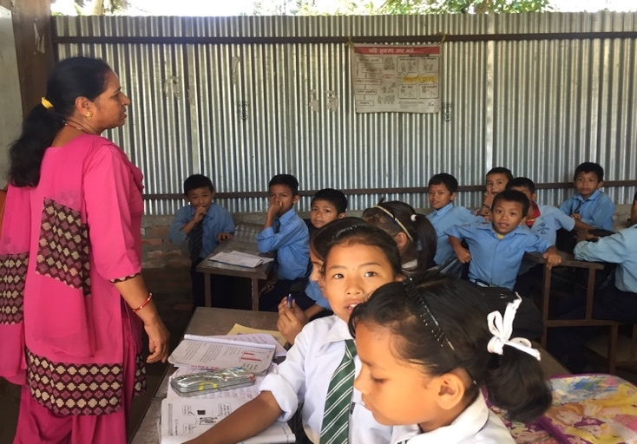 | 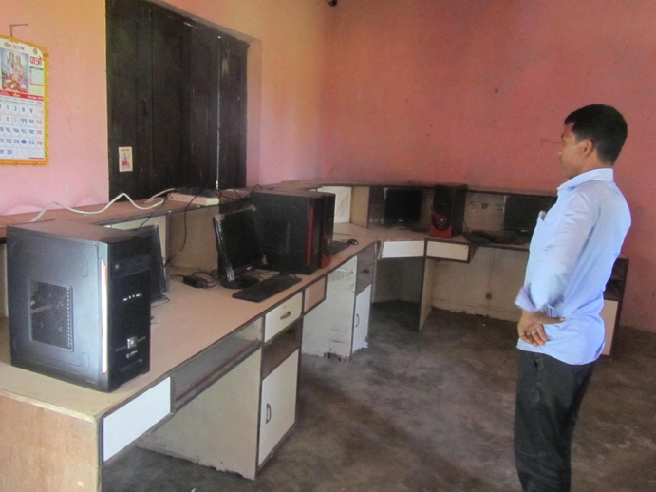
School running in temporary learning center | Insufficient computer lab
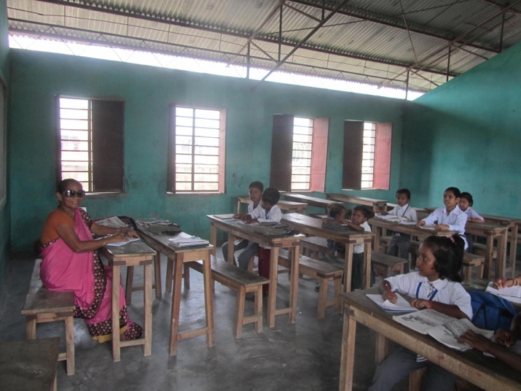 | 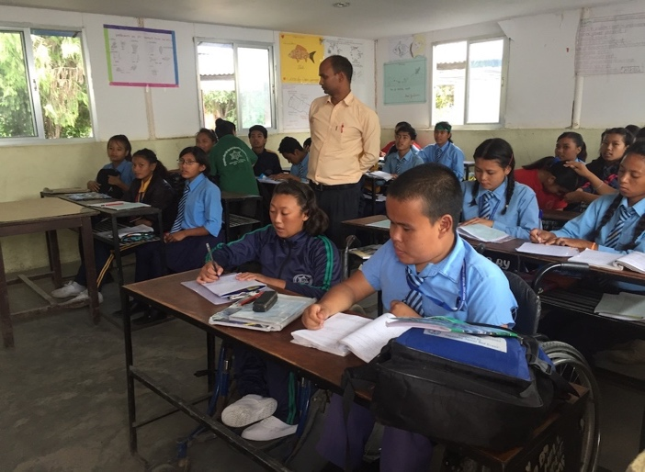
Classroom | Inclusive school
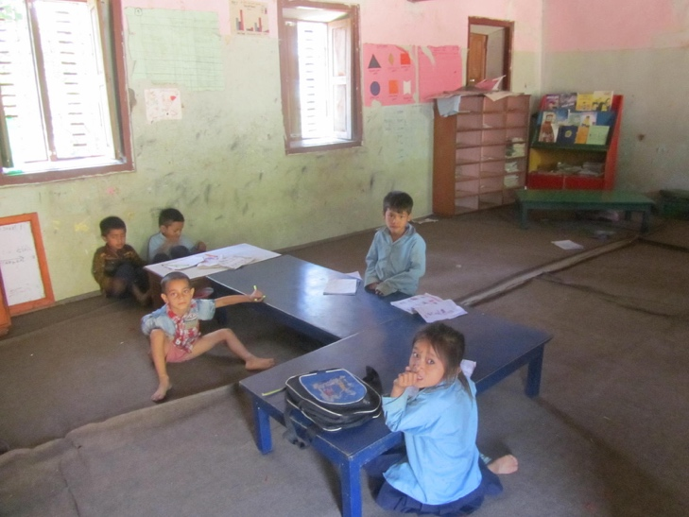 | 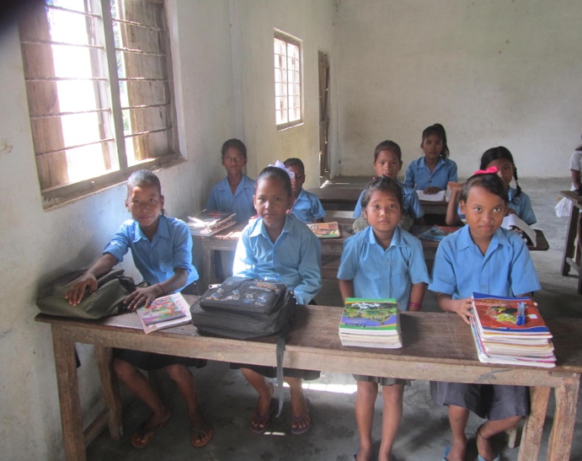
Almost no study materials in ECED | More girl child in community school
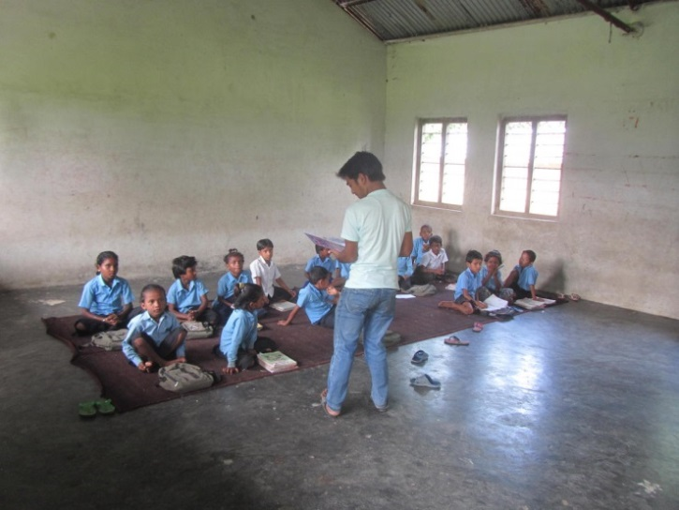 | 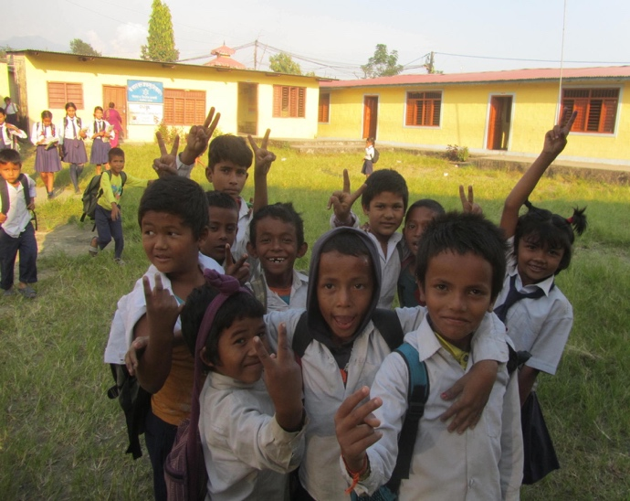
Children (mostly marginalized) in the classroom | Mostly marginalized children at school ground

These are the objectives stated in the Nepal’s large scale systemic interventions to reform education sector. For the details and further information regarding the reforms, see MoE (1990, 1991, 1999, 2002, 2003, 2008)
See Flash I (2016) report of the academic year 2016/17 published by Department of Education. Flash report is comprehensive report prepared by DoE based on the Education Management Information System (EMIS) which comprises the detailed school based data and consolidated in single reporting format.
Central Bureau of Statistics (CBS), 2011
Consolidated Equity Strategy (MoE), 2014
ibid. The equity strategy highlighted three equity areas as: equity in meaningful access, equity in participation, and equity in meaningful learning outcomes. It further describes eight equity dimensions as: gender, socio economic status, health and nutrition status, geographical location, disabilities, ethnic group and or cast, language and children of vulnerable groups. See policy analysis chapter for details analysis.
See VCDF (DoE) 2009. Vulnerable Community Development Framework has been developed by Ministry of Education in 2009 to implement the School Sector Reform Plan. Refer the VCDF for details.
See All Children in School, Global Initiative on Out on School Children (MoE) 2016. This report showed the comprehensive picture of out of school children and multiple dimensions of analyzing this issue.
ibid. The report identified nine different barriers however the number of barriers can be changed since these are dynamic and changeable during the course of the time.
See, National Assessment of Student Achievement (MoE, ERO) 2015. The study has conducted for the basic education learning achievement, in particular on grade 3 and 5.
This new Inclusive Education Policy (2017) has replaced the Special Education Policy 1996. The latest one is more comprehensive to incorporate all other provisions made in UN conventions in which Nepal is a party and Nepal’s latest changes legal framework.
The strategy has been developed after wider consultation with multiple stakeholders in the education sector. The equity framework was pertinent foundation for other educational interventions. Equity Strategy (2014)
See, SSRP (2009)
See UNICEF (2000), Defining Quality in Education
Interview with District Education Officer
Interview with Out of School Children with Disability
Interview with secondary level student with disability
Interview with Head Teacher of one of the Secondary Schools
‘Rahaat Teacher’ is a relief quota teacher provided by government if there is no permanent or temporary position
Interview with Head Teacher
Interview with School Supervisor
Conversation in Focus Group Discussion
Interview with parents of children with disability
See, Flash I Report (2016/2017)
Interview with Chairperson of School Management Committee
The approach treats group of the people equally without considering the differences in multiple aspects

